Continuing Education Program

Centre for Computing and Information Technology

Faculty of Engineering – University of Indonesia

Tel: 021-7863508 Mail: ccit.@eng.ui.ac.id

**CHATIFY**

**Created By:**

Christian Frans Mukuan (1920010040)

Deyaninta Ekabriela Permata (1920010050)

Class

3SC3

Faculty

Riza Muhammad Nurman S.Kom

.

**Developed by :**

1. Christian Frans Mukuan (1920010040)
2. Deyaninta Ekabriela Permata (1920010050)



**PROJECT ON**

*Chatify*

.

Batch Code : 3SC3 (Group 7)

Start Date : October 8, 2020

End Date : October 25, 2020

Date of Submission : October 27, 2020

Name of Faculty : Riza Muhammad Nurman S.Kom

Names of Developer :

1. Christian Frans Mukuan (1920010040)
2. Deyaninta Ekabriela Permata (1920010150)



**CHATIFY**

.



**CERTIFICATE**

This is to certify that this report titled “Chatify” embodies the original work done by Christian Frans Mukuan, and Deyaninta Ekabriela Permata in partial fulfillment of their course requirement at NIIT.

Coordinator :

Riza Muhammad Nurman S.Kom

.

**ACKNOWLEDGEMENT**

First of all, thanks to Allah SWT because we can complete this Project task both in the form of a presentation. We want to deliver sincere especially for Mr. Riza Muhamad Nurman’s faculty and another faculty who always help. Thank you also to fellow students who have supported, and also thank you for being fellow workers in the education at CCIT-FTUI.

The Project paper entitled ‘Chatify' the writers submits as Project's 2020 task requirements.

The hope of the writers hopefully this paper can be useful for all so that it can add knowledge and insight. The writers realize that this paper is far from perfect. Therefore, the writers expect all suggestions and criticisms from readers who are constructive for the perfection of this paper.

Depok, October 2020

Writers

Coordinator :

Muhamad Hudya Ramadhana

.

**SYSTEM ANALYSIS**

**System Summary :**

Social media refers to websites and applications that are designed to allow people to [share content quickly](https://www.thebalancesmb.com/how-to-use-instagram-stories-for-small-business-4768463), efficiently, and in real-time. While many people access social media through smartphone apps, this communication tool started with computers, and social media can refer to any internet communication tool that allows users to broadly share content and engage with the public.

Therefore, the author of this project makes a project about the website of social media, named Chatify. Chatify reshapes communication around the globe, allowing you to enjoy not only messaging but also free voice and video calls wherever you find yourself.So, on this website, the user can register their account and buy some stickers to make the communication more fun. The user can also see some articles about the world in the Chatify News. This website made by author with using Netbeans, JSF, Hibernate, and MySQL.

.

**TECHNOLOGY DIAGRAM**

Top Level Diagram representing the technologies used to develop application.

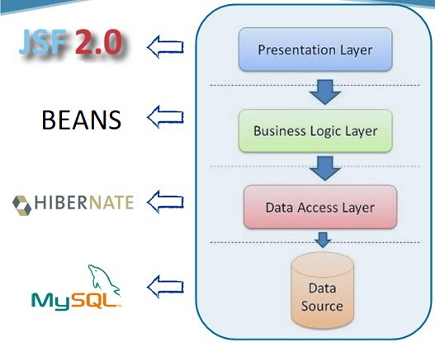

.

**SCHEMATIC DIAGRAM**

**Database Name**: Chatifyhibernate

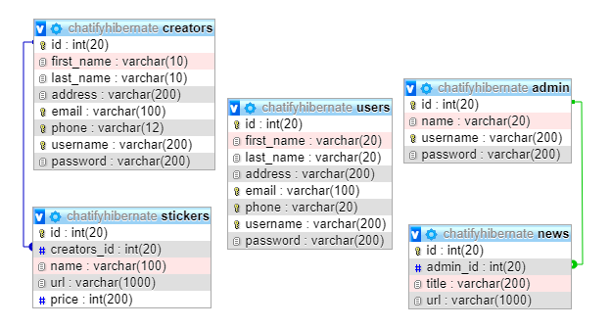

.

1. Homepage

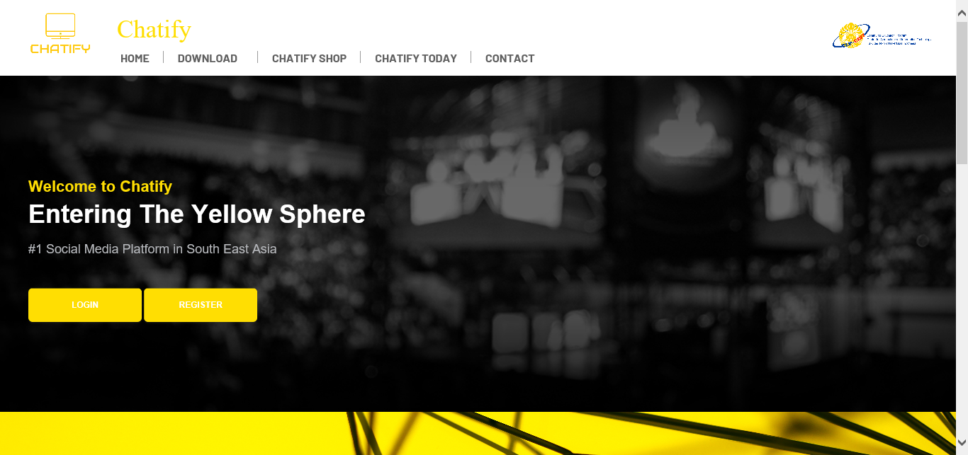

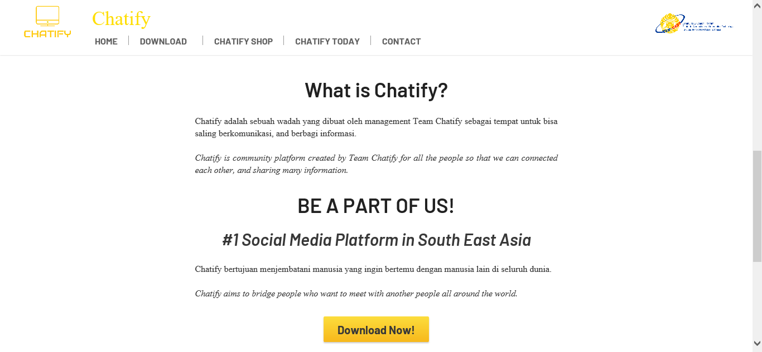

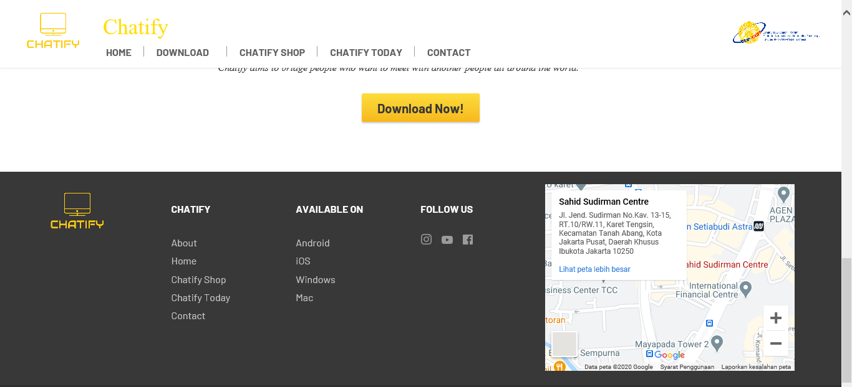

**USER INTERFACE DESIGN**

.

1. Login Page for Users

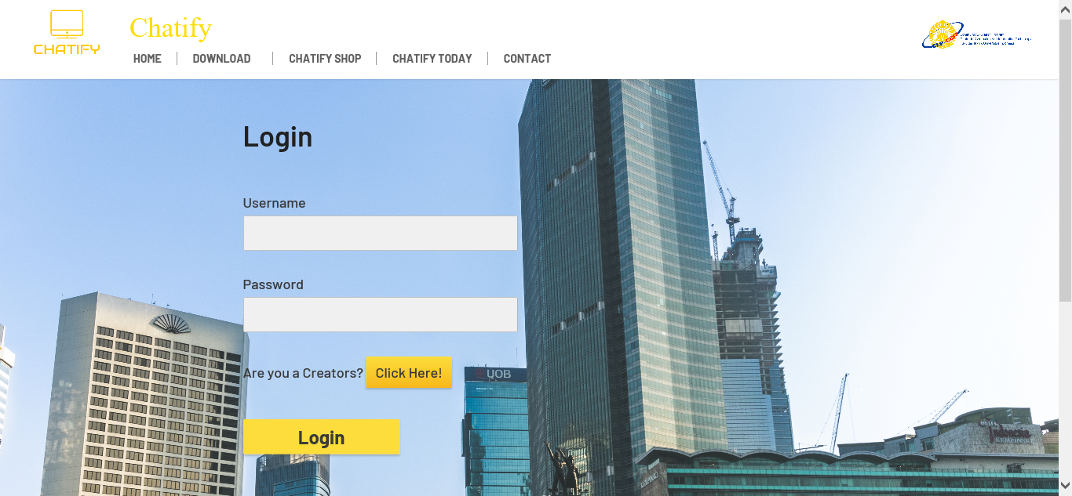

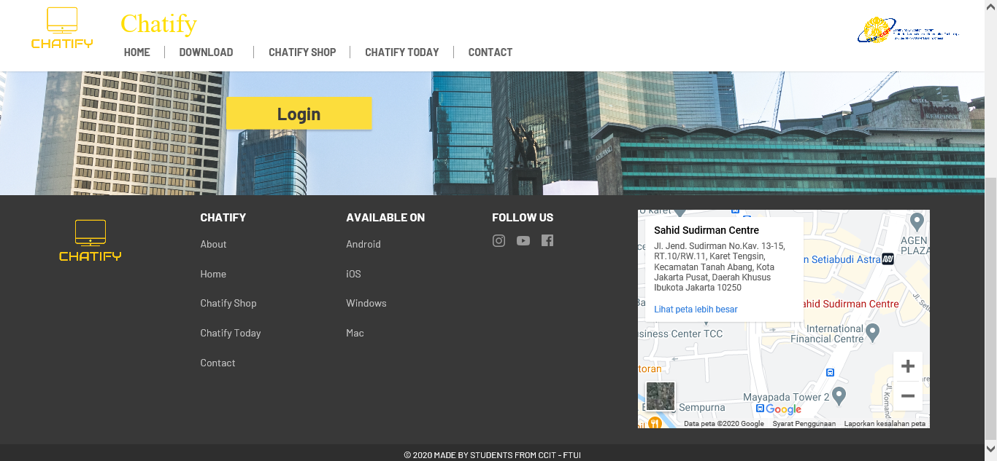

1. Login Page for Creators

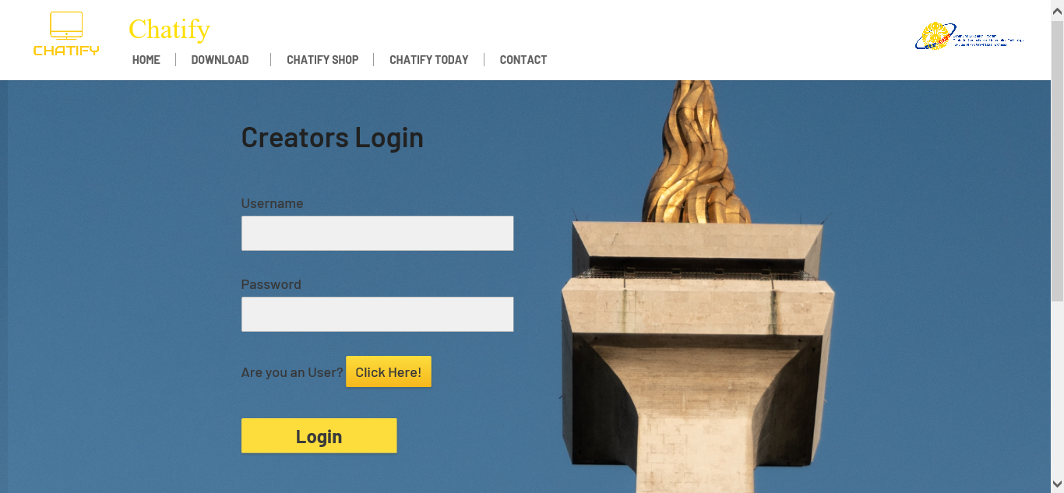

**TABLE DESIGN**

.

1. Register Page

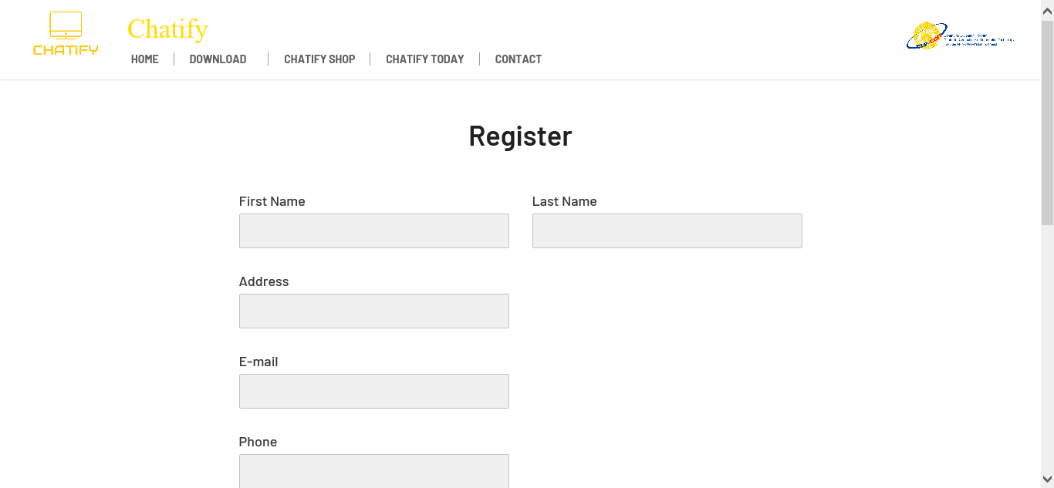

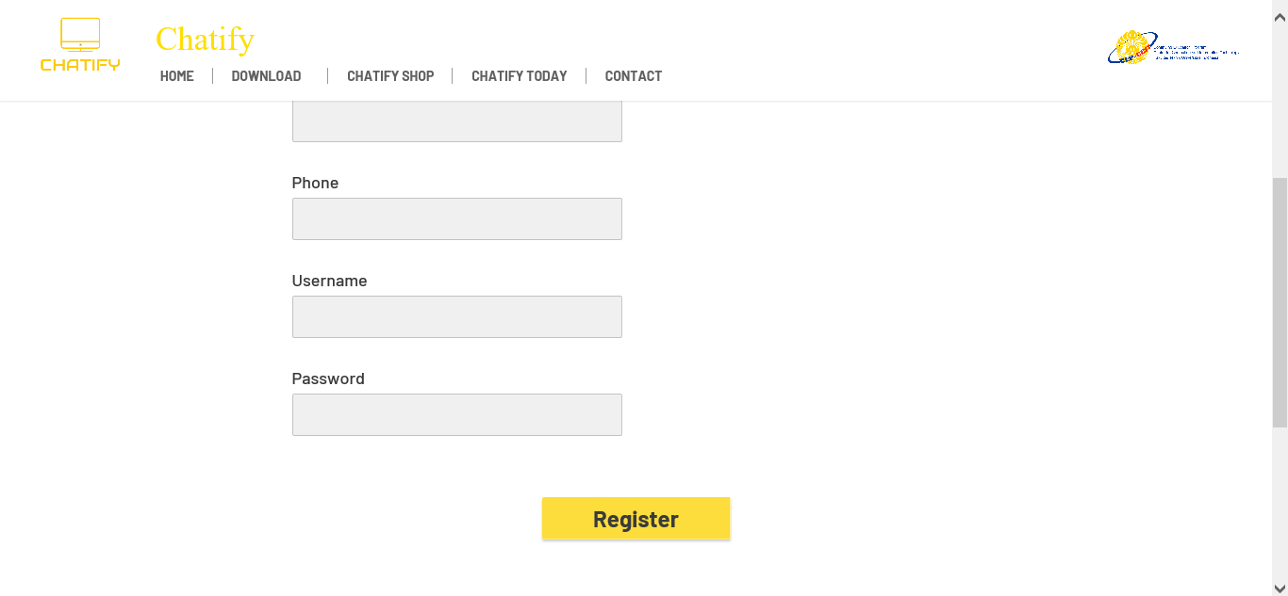

1. Download Page (Ios)

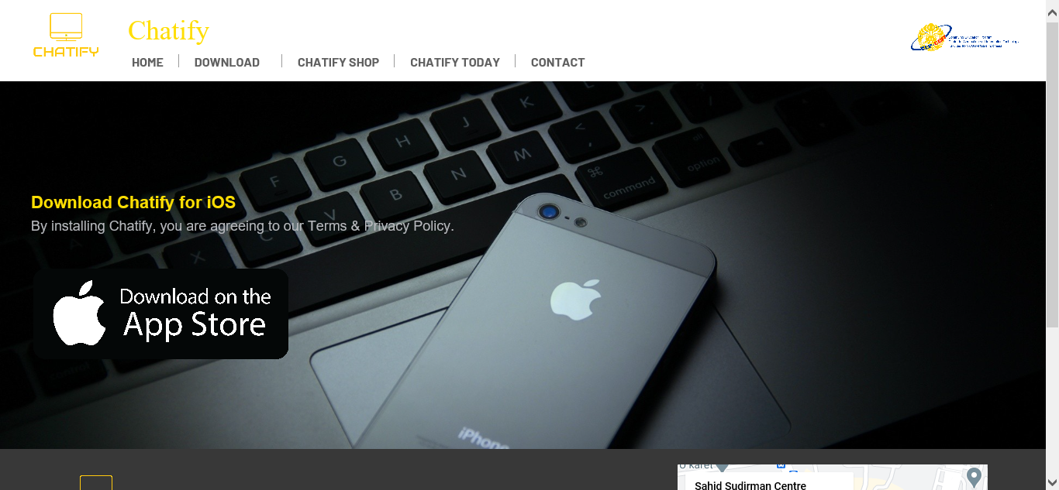

**TABLE DESIGN**

.

1. Download Page (Android)

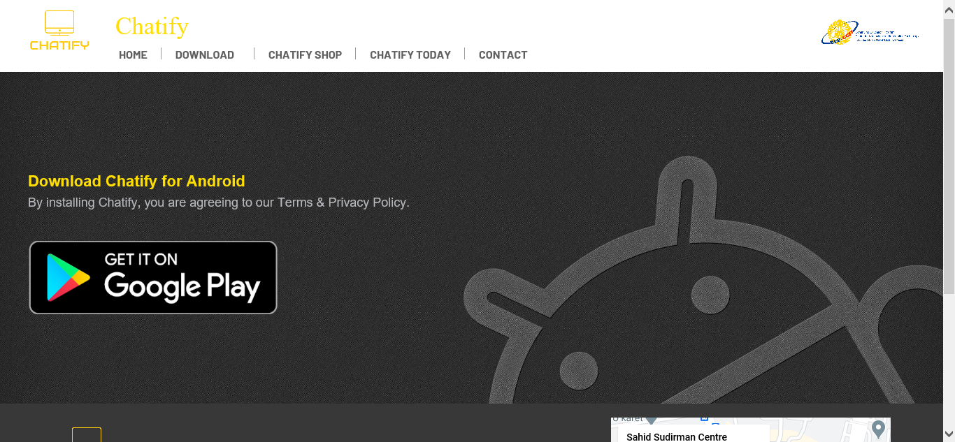

1. Download Page (Window)

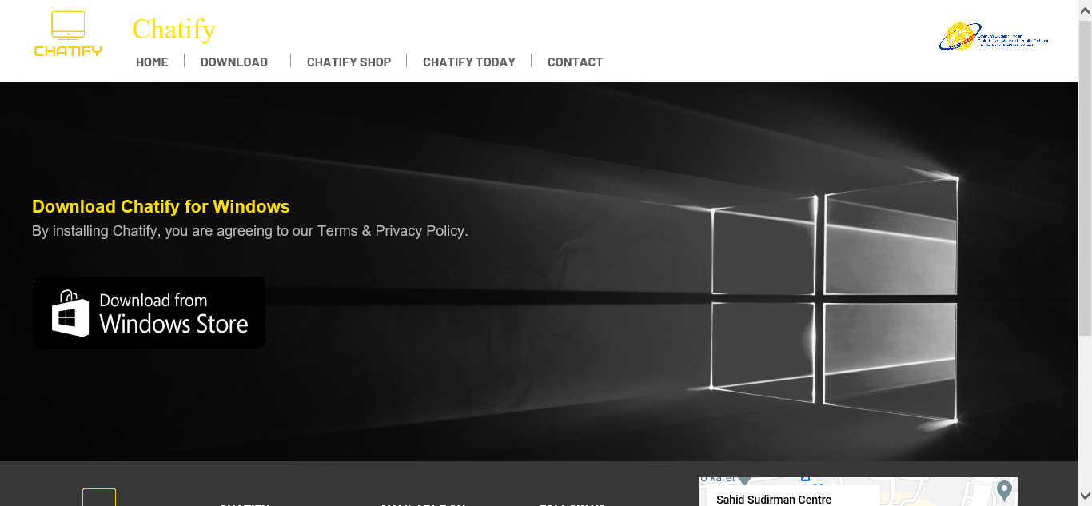

1. Download Page (Mac)

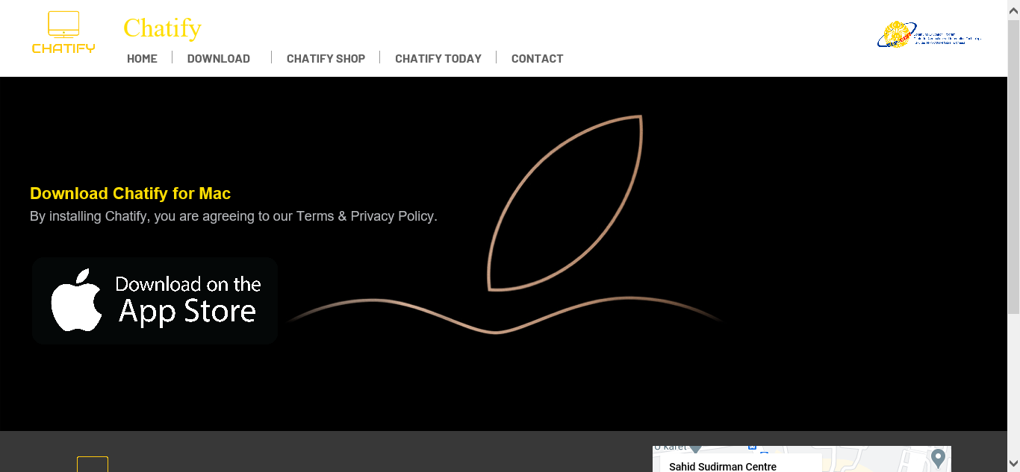

.

1. News Page

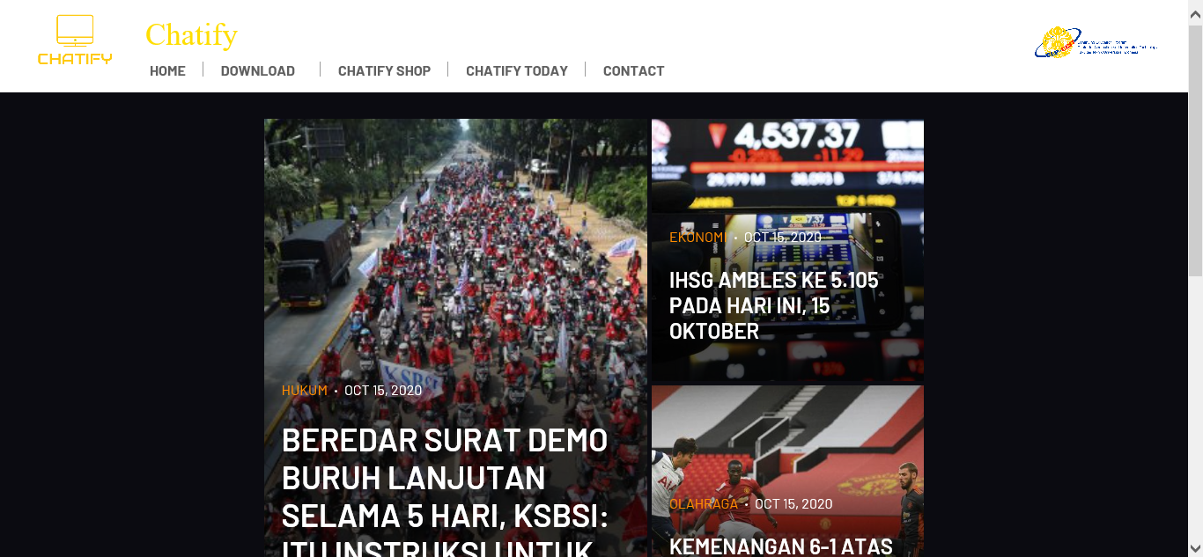

1. Creators Page

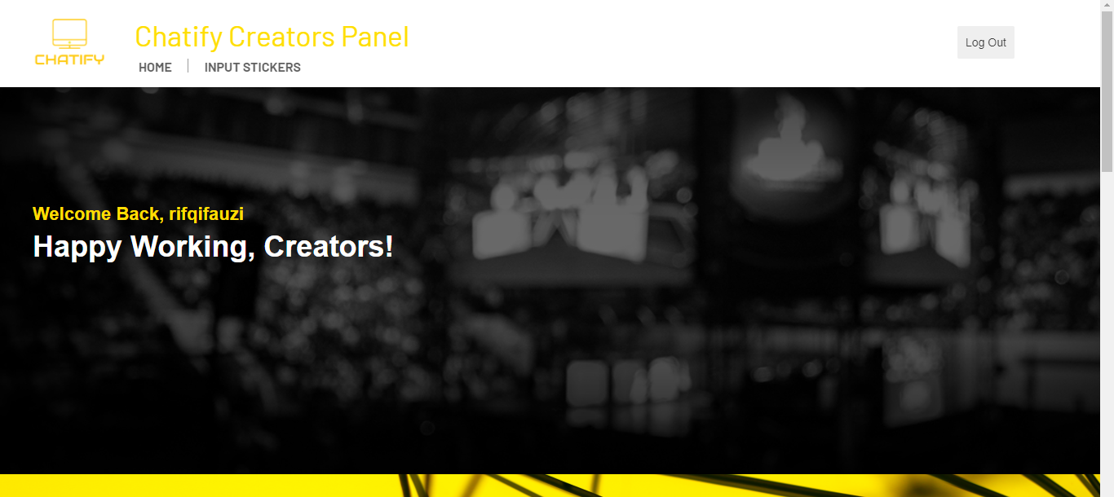

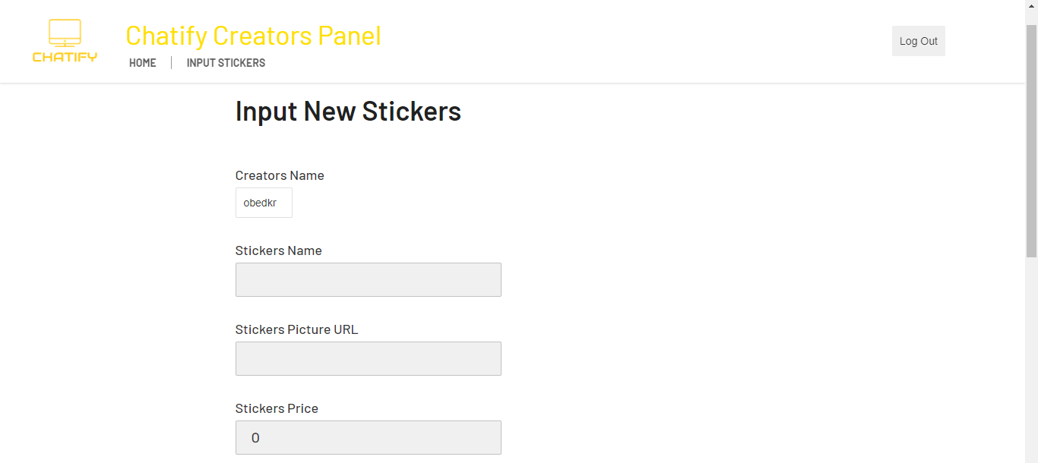

.

1. Users Page

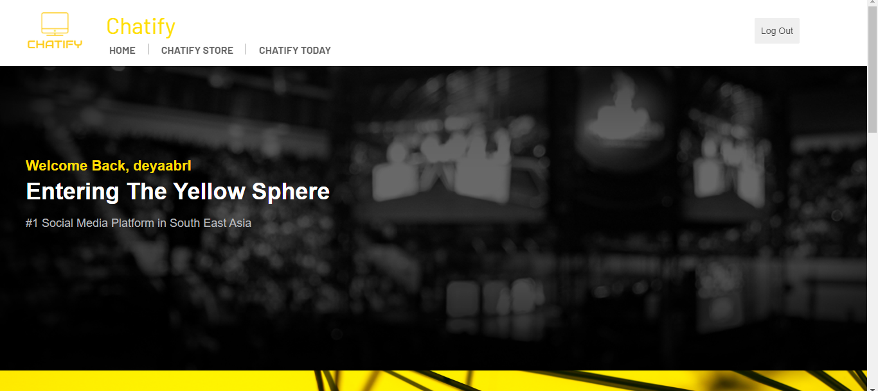

1. Chatify Store

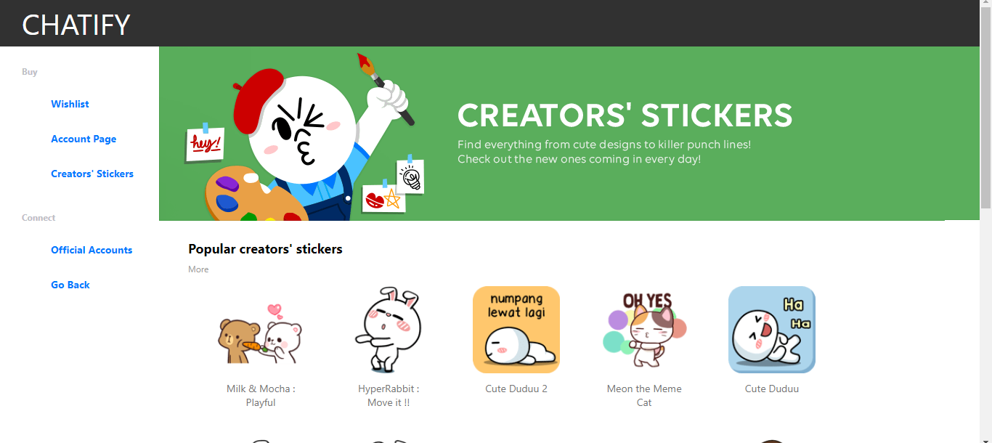

1. Admin Page



1. Database Page

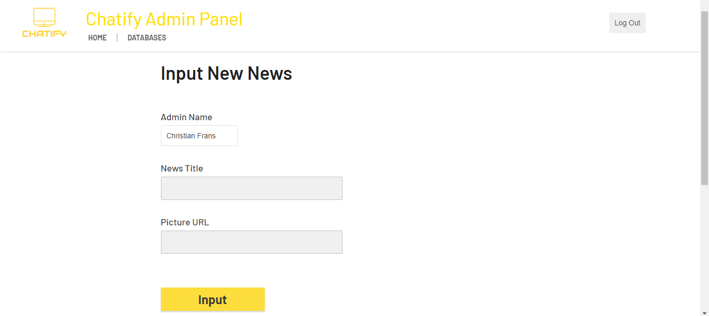

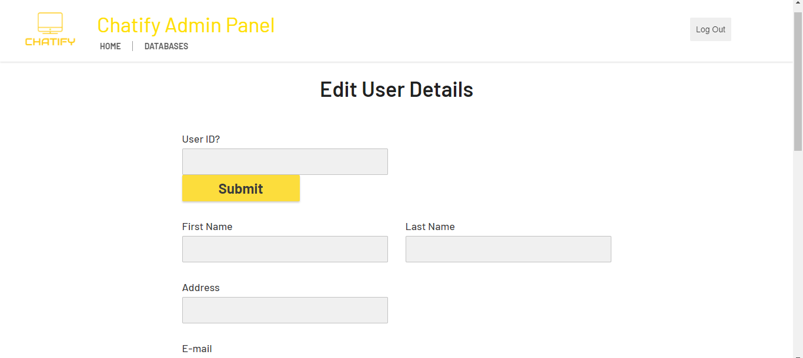  
  
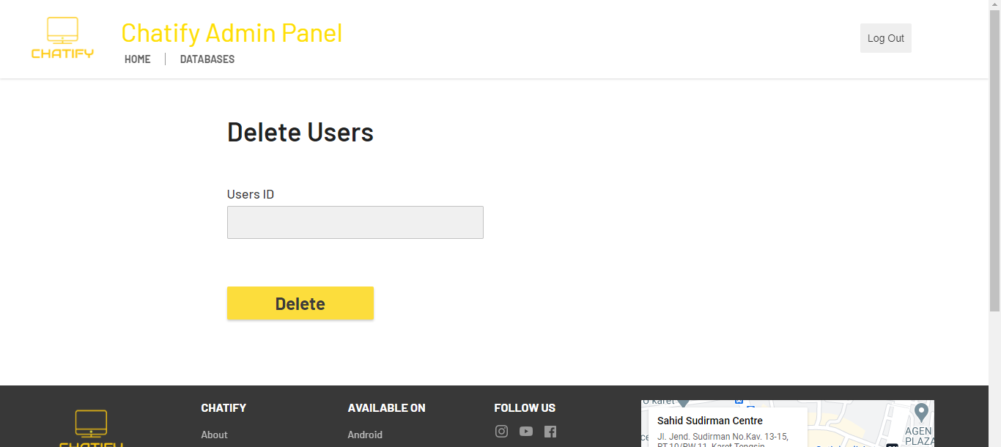

1. About Page

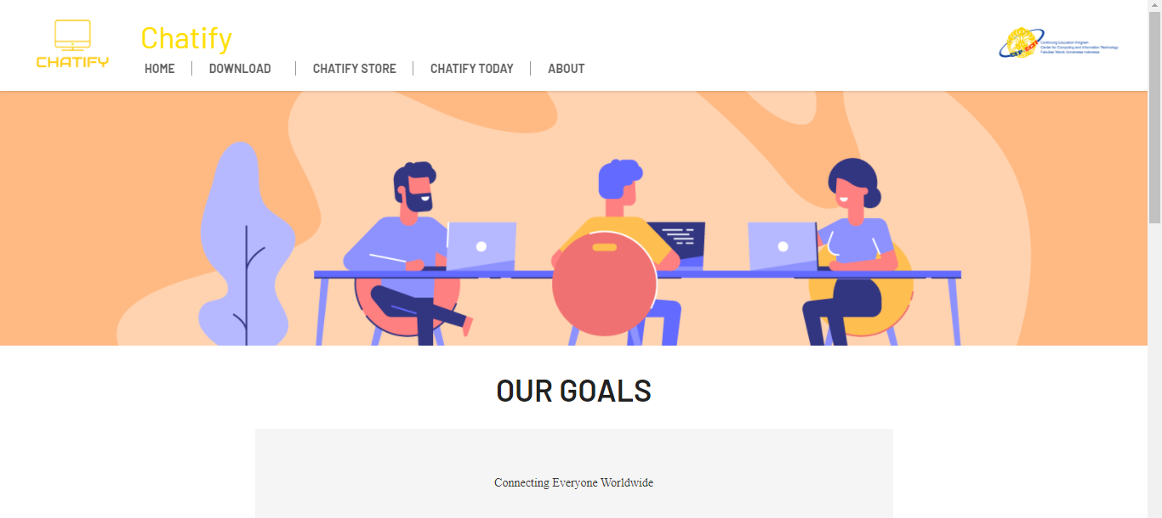

**CONFIGURATION**

**Hardware** :

ASUS A442UR Intel® Core™ i5-8250U

**Operating System** :

Windows 10 Home Single Language 64-bit (10.0, Build 18362)

**Software** :

Netbeans IDE 8.2

|  |  |  |
| --- | --- | --- |
| **PROJECT FILE DETAILS** | | |
| **S.No** | **File Name** | **Remarks** |
| 1. | Chatify.docx | To show the contents of the project in detail |
| 2. | Chatify.pptx | To show and explained the content of the project |
| 3. | chatifyhibernate.sql | To make the query of the project database |
| 4. | WebsiteChatify.rar | To show, simplify processes or procedures to make a website. |